POWER BI DASHBOARD CHALLENGE
TASK 5 – ADVANCED DAX
● Create measures using time intelligence functions.
● Create measures for comparisons across time periods.
● Create measures to calculate growth or percentage change.
● Create measures to perform ranking and top N analysis.
● ✅ Task: Develop at least 3–5 advanced measures and apply them in visuals.
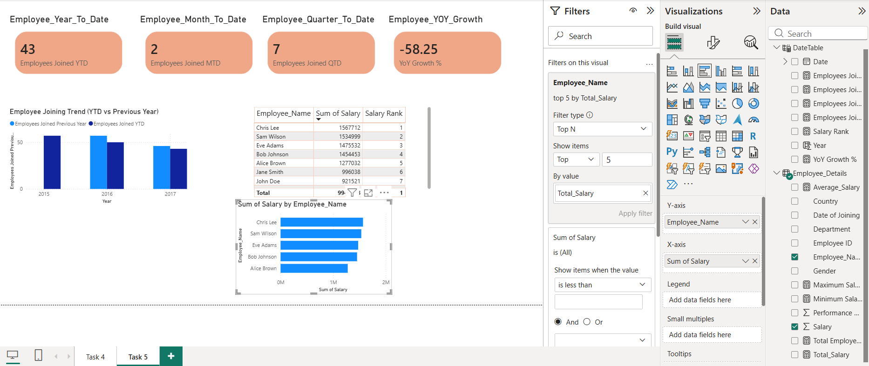
OBSERVATION:
1. Advanced DAX measures were created using Time Intelligence functions such as YTD, MTD, and QTD.
2. Employee joining trends were analyzed across different time periods using the Date of Joining column.
3.A Year-over-Year (YoY) Growth % measure was created to compare employee joins with the previous year.
4. A Salary Rank measure was created using the RANKX function to rank employees based on salary.
5. A Top 5 Employees by Salary analysis was performed using a bar chart.
6. Card visuals were used to display key metrics such as YTD, MTD, QTD, and YoY Growth.
7. A column chart was created to compare employee joining trends across years.
8. A table visual displayed employee names, salaries, and salary rankings for detailed analysis.
9. The advanced DAX measures provided dynamic and interactive insights into employee growth and salary distribution.
10. The report successfully meets the Advanced DAX requirements by combining time intelligence, comparison, growth analysis, ranking, and Top N analysis using appropriate visuals.

